LAB 2 ANP-C7781

Solve following questions:

1. Write a program that takes a student's score as input and outputs the corresponding grade based on the following scale.

A: 90-100

B: 80-89

C: 70-79

D: 60-69

F: 0-59

Program:-

package Day07;

import java.util.Scanner;

public class StudentScore {

public static void main(String[] args) {

Scanner read = new Scanner(System.***in***);

// Taking age as an input

System.***out***.print("Enter the age :- ");

int age = read.nextInt();

// Checking the grades according to age using nested if else

if (age >= 90 && age <= 100) {

System.***out***.println("A");

} else if (age >= 80 && age <= 89) {

System.***out***.println("B");

} else if (age >= 70 && age <= 79) {

System.***out***.println("C");

} else if (age >= 60 && age <= 69) {

System.***out***.println("D");

} else if (age >= 0 && age <= 59) {

System.***out***.println("F");

} else {

System.***out***.println("Invalid Age, Please enter the valid age..");

}

read.close();

}

}

Output :-

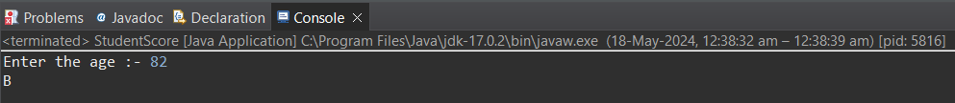

1. Write a program to check if a given year is a leap year. (A year is a leap year if it is divisible by 4 but not by 100, or it is divisible by 400.)

Program :-

package Day07;

import java.util.Scanner;

public class LeapYear {

public static void main(String[] args) {

// Taking year as an input

Scanner read = new Scanner(System.***in***);

System.***out***.print("Enter the year :- ");

int year = read.nextInt();

// Checking whether year is leap or not using if else

if (year % 4 == 0 && year % 100 != 0 || year % 400 == 0) {

System.***out***.println(year + " is a leap year");

} else {

System.***out***.println(year + " is not a leap year");

}

read.close();

}

}

Output :-

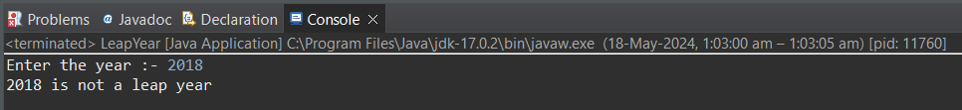

1. Write a program that takes an integer as input and checks if it is positive, negative, or zero.

Program :-

package Day07;

import java.util.Scanner;

public class PositiveNegativeZero {

public static void main(String[] args) {

// Taking number as an input

Scanner read = new Scanner(System.***in***);

System.***out***.print("Enter the number :- ");

int num = read.nextInt();

// Checking whether input is Negative, Zero or Positive number using if else

if (num < 0) {

System.***out***.println(num + " is a negative number");

} else if (num == 0) {

System.***out***.println(num + " is a zero number");

} else {

System.***out***.println(num + " is a positive number");

}

read.close();

}

}

Output :-



1. Write a program that prints numbers from 1 to 10 using a loop.

Program :-

package Day07;

public class Loop1To10 {

public static void main(String[] args) {

// Displaying the message

System.***out***.println("1 To 10 Numbers Using Loop :- ");

System.***out***.println("");

// Printing 1 to 10 numbers using loop

for (int i = 1; i <= 10; i++) {

System.***out***.println(i);

}

}

}

Output :-

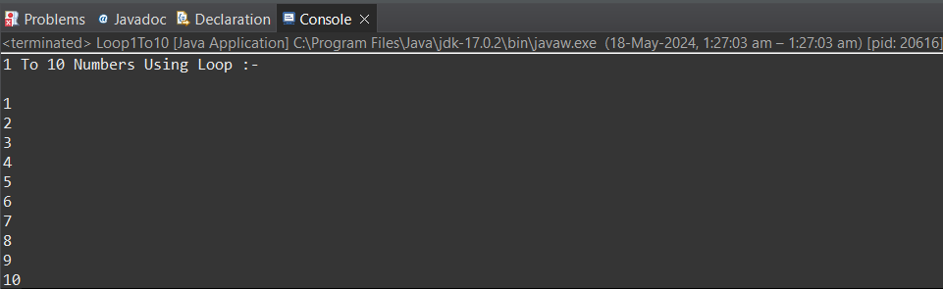

1. Write a program that takes an integer N as input and calculates the sum of entered numbers.

Program :-

package Day07;

import java.util.Scanner;

public class NumSum {

public static void main(String[] args) {

// Taking two numbers as an input

Scanner read = new Scanner(System.***in***);

System.***out***.println("Enter the first number :- ");

int num1 = read.nextInt();

System.***out***.println("Enter the second number :- ");

int num2 = read.nextInt();

// Doing operations

int sum = num1 + num2;

// Printing the result

System.***out***.println("The sum of entered number :- " + sum);

read.close();

}

}

Output :-

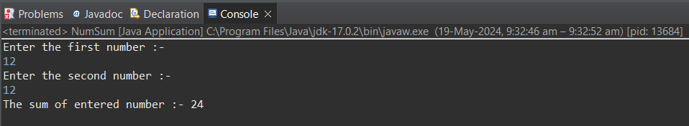

1. Write a program that takes an integer as input and prints its multiplication table up to 10.

Program :-

package Day07;

import java.util.Scanner;

public class Multiplication {

public static void main(String[] args) {

// Taking number as an input

Scanner read = new Scanner(System.***in***);

System.***out***.print("Enter the number :- ");

int num = read.nextInt();

// Using for loop to printing multiplication table

for (int i = 1; i <= 10; i++) {

int result = num * i;

System.***out***.println(num + " X " + i + " = " + result);

}

read.close();

}

}

Output :-

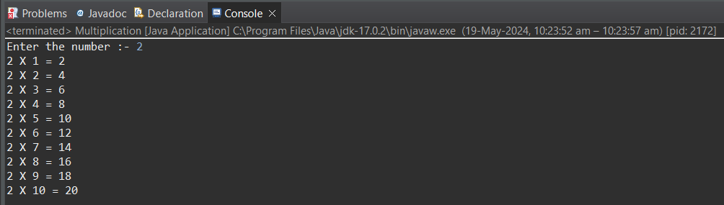

1. Write a program that takes a positive integer as input and prints its digits in reverse order.

Program :-

package Day07;

import java.util.Scanner;

public class ReverseDigit {

public static void main(String[] args) {

// Taking number as an input

Scanner read = new Scanner(System.***in***);

System.***out***.print("Enter the number :- ");

int num = read.nextInt();

int remainder;

// Reversing the number using while loop

while (num > 0) {

// Identifying last digit of number using remainder method

remainder = num % 10;

// Printing the identified value using remainder method

System.***out***.print(remainder);

// Removing last digit after printing it

num = num / 10;

}

read.close();

}

}

Output :-

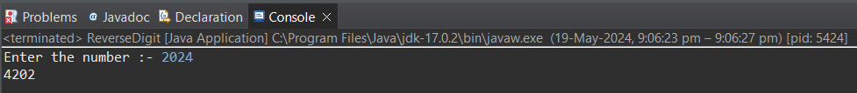

1. Create a class Animal with a method makeSound() that prints "Some generic animal sound". Create another class Dog that extends Animal and overrides the makeSound() method to print "Bark". Write a main method to demonstrate calling the makeSound() method on an Animal reference holding a Dog object.

Program :-

package Day07;

//Animal Class Created

class animal {

public void makeSound() {

System.***out***.println("some generic animal soound");

}

}

//Dog Class Created which extends Animal Class and also overrides the makeSound Function

class dog extends animal {

*@Override*

public void makeSound() {

System.***out***.println("Bark");

}

}

public class AnimalDogClass {

public static void main(String[] args) {

// Animal reference created holding an dog object

animal dog = new dog();

// Invoking the makeSound function with the help of animal reference

dog.makeSound();

}

}

Output :-

